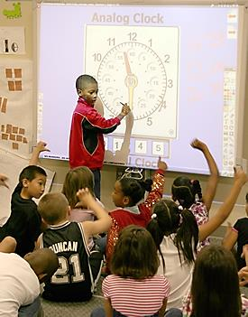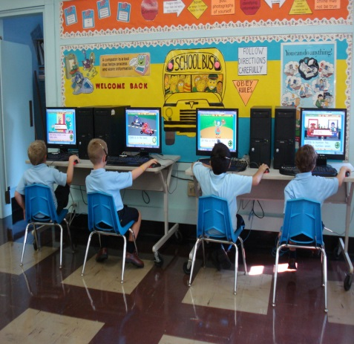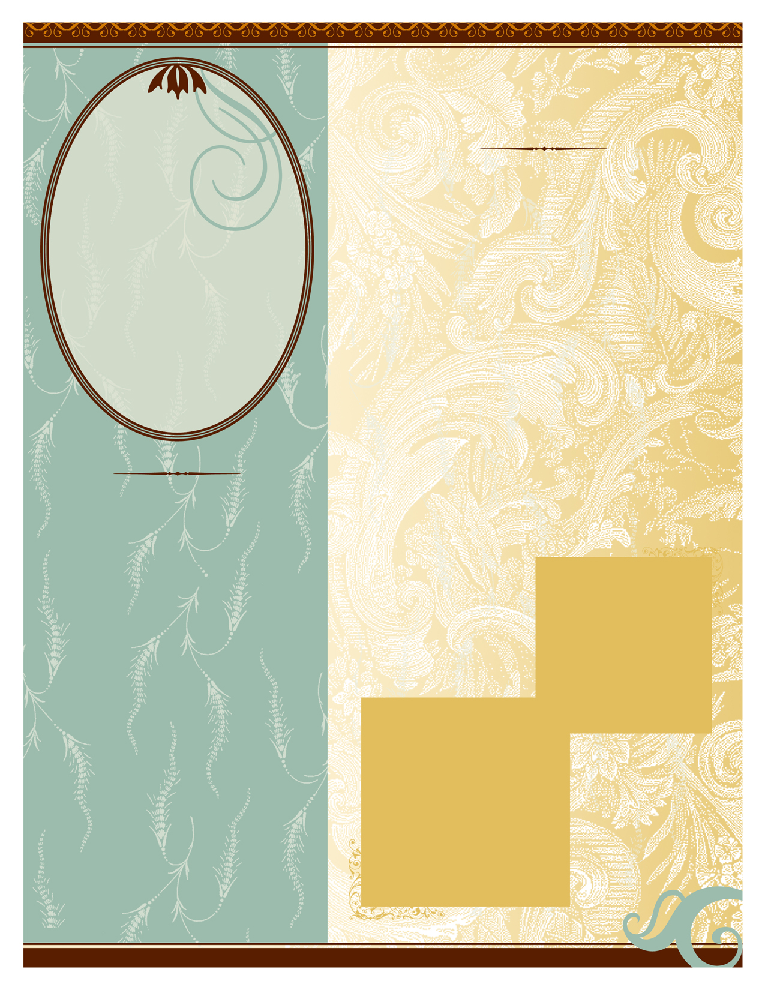

Technology in the classroom is becoming more prevalent in the modern world. Teaching children at a young age how to use these technologies is becoming more important and vital to their future successes.

Throughout the grades of Pre-K through 2nd grade, students are just beginning to learn about technology and its uses. We are doing what we can to prepare them for their future classes and higher education not only through basic skills such as Math, Science, and Reading, but also through becoming Technologically Literate. Some of the ways we will be doing this is by having the students do the following activities:

* Show and tell their own ideas and stories through digital tools and media resources.
* Use digital media to complete research projects about the environment, history, and other important subjects.
* Engage in learning activities with children from multiple cultures through e-mail and other electronic means.
* Work in groups to complete media presentations as a team.
* Use technological simulations and graphical organizers to explore and depict various science projects.
* Learn and show safe and cooperative use of technology.
* Independently problem solve through the use of digital tools and resources.
* Learn to communicate about technology using appropriate and accurate terminology.
* Learn and apply an

ability to navigate in

virtual environments

such as electronic books,

simulation software, and

websites.

Common Core Grades PK-2

Teaching Technology to Students

Ms. Kelsie Howe

*“There can be infinite uses of the computer and of new age technology, but if teachers themselves are not able to bring it into the classroom and make it work, then it fails.”*

- Nancy Kassebaum